New for 2019: Howa MiniAction Rifle in .300 BLK
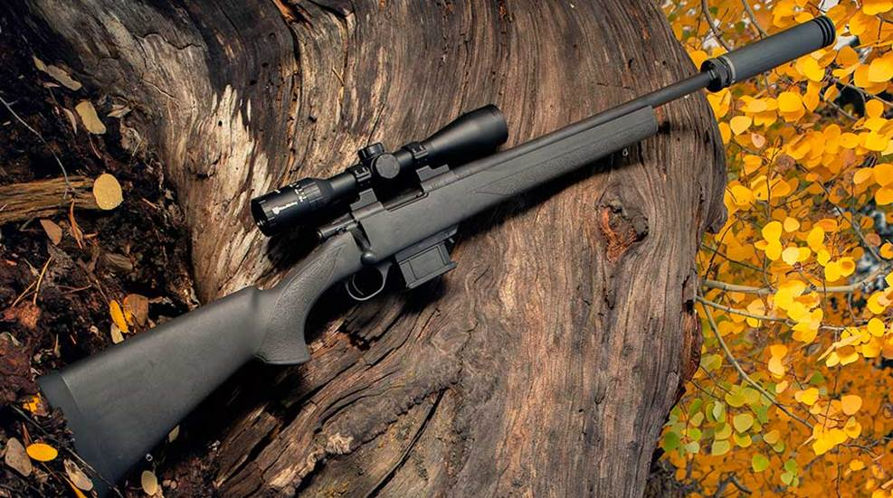
When it comes to the .300 BLK cartridge, most firearm enthusiasts equate the round with the popular AR-15 platform. Of course, the .300 BLK was developed with the AR-15 in mind, giving users a larger, .30-caliber projectile that could hit harder than the 5.56 NATO and provide an opportunity for subsonic use. However, with the growing popularity of this cartridge, many manufacturers are branching out into other platforms, such as the Legacy Sports International Howa MiniAction rifle chambered in .300 BLK.
Unlike most rifles chambered for the .300 BLK, the Howa MiniAction is a bolt-action platform that's smaller than the traditional short-action receivers usually seen in the bolt-rifle world. These even-shorter rifles are optimized to feed many of today's popular AR-length cartridges, and the .300 BLK is one of the latest chamberings in the MiniAction lineup, which also includes options chambered in .223 Rem., 6.5 Grendel and 7.62x39 mm.
Ultimately, the principle benefit of having a bolt-action rifle chambered in .300 BLK is to take advantage of the many subsonic offerings on the market. These quiet rounds, combined with a suppressor, have made .300 BLK rifles popular among shooters looking to achieve the most sound-reduction possible in their rifle platform. However, today's AR-15s, equipped with semi-automatic operating systems, feature internal mechanisms that still create loud noises, particularly when the bolt closes on locking lugs. A bolt-action rifle like the Howa MiniAction removes this variable, allowing users to have an incredibly quiet platform.
Each Howa MiniAction chambered in .300 BLK is ideally suited to serve as a suppressor platform, having been equipped with a 16.25-inch heavy barrel topped with a threaded muzzle. Muzzle threads are cut with a 5/8x24 TPI thread pitch, which is compatible with most of today's .30-caliber sound suppressors. When equipped with a sound suppressor, hunters in particular can take advantage of this quiet platform while in the woods, enabling them to take game without spooking other animals in the area or damaging their hearing.
The other benefit of a .300-BLK, bolt-action platform like the Howa MiniAction is for new shooters, who may be both sound- and recoil-averse. The AR-length cartridge chambered in a heavy-barreled rifle produces little felt recoil, and the use of subsonic ammunition combined with a solid suppressor makes for an easy, comfortable starting point for those stepping into the shooting sports.
Each Howa MiniAction rifle chambered in .300 BLK is set inside of an HTI synthetic stock, complete with a pillar-bedded action and recoil pad. The stock is textured along the fore-end and wrist and features sling-swivel studs at the front and rear. Each rifle is equipped with a proprietary, detachable magazine holding 10 rounds. Length-of-pull measures 13.87 inches, and the overall length of the rifle measures 35.75 inches. Each rifle is equipped with the company's HACT two-stage trigger, short bolt throw and a three-position safety.

